How to add an observation on Tapestry

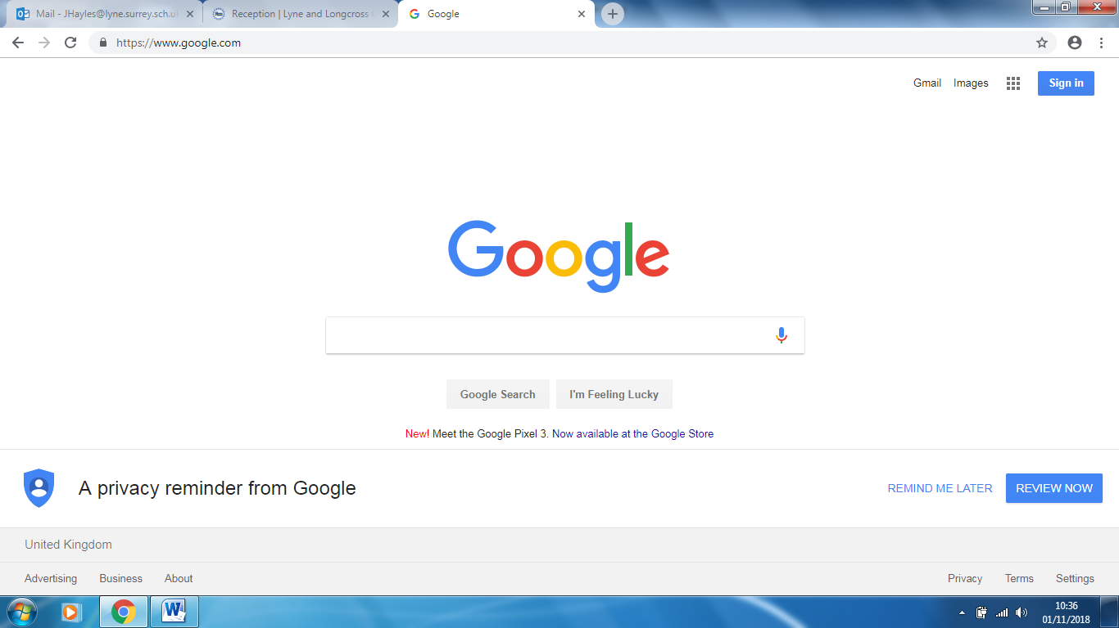

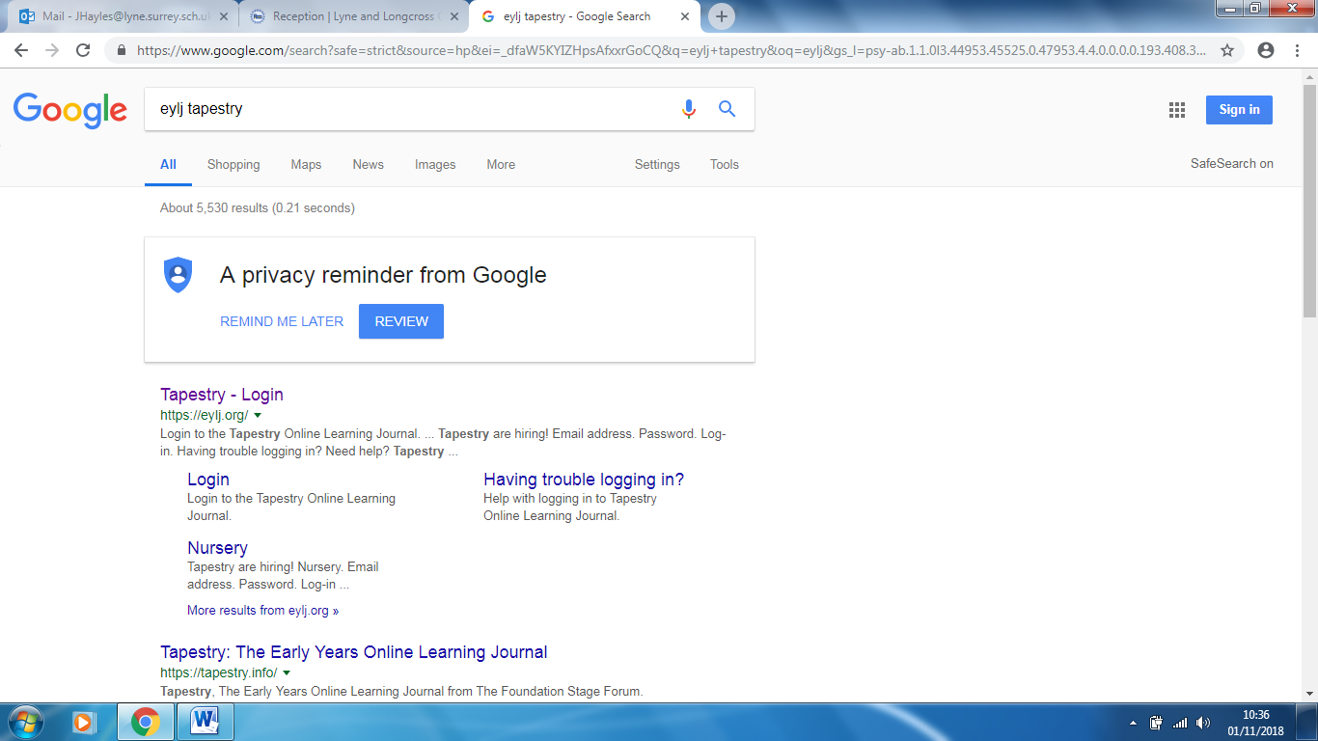
Type ‘eylj tapestry’ into Google. Then click on ‘Tapestry – Login’.
Open ‘Google’.
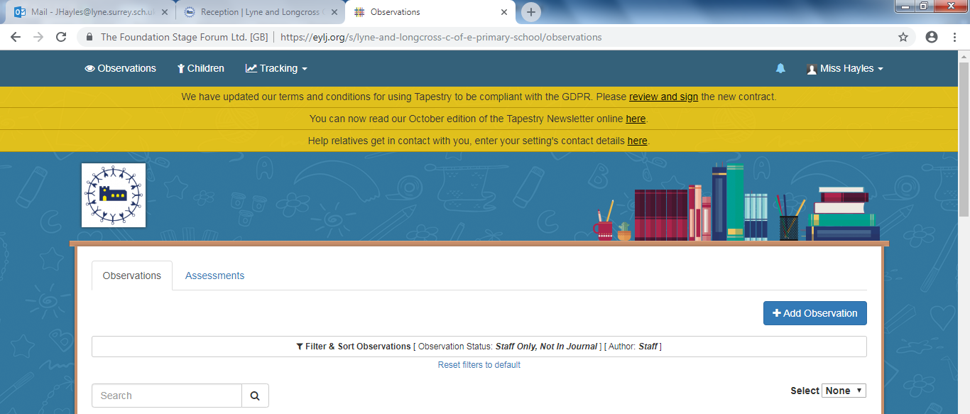
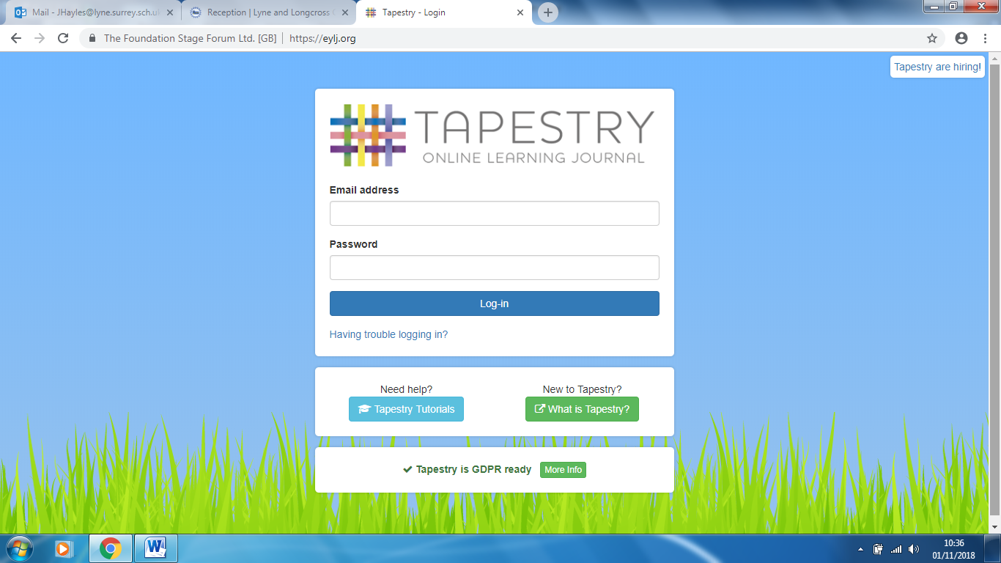
Login to Tapestry (if you have forgotten your password please ask and then I can send a link for you to be able to reset your password).
Then click on ‘Add Observation’.
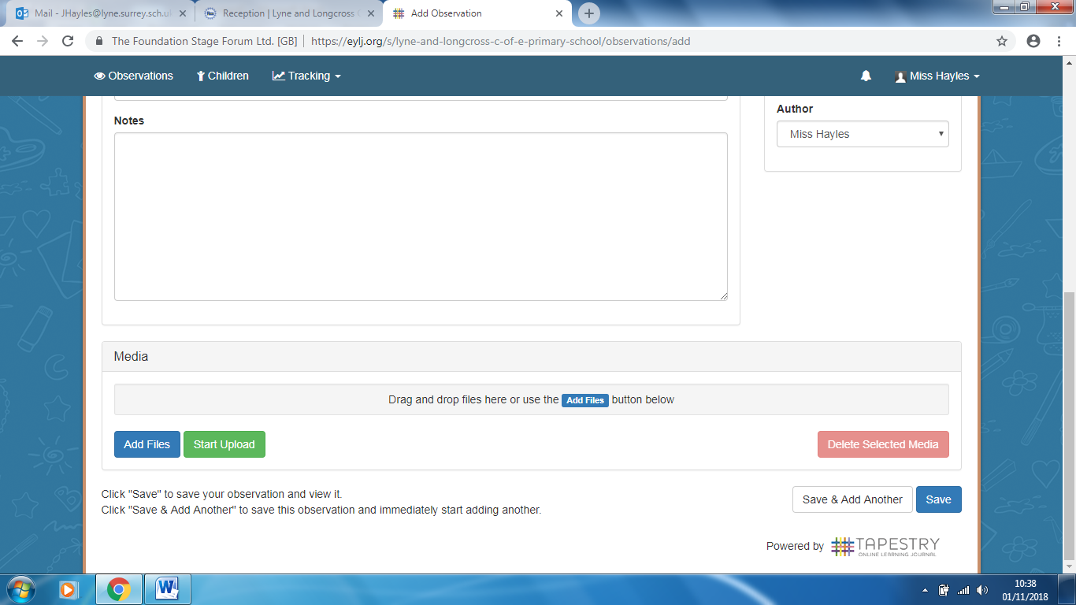
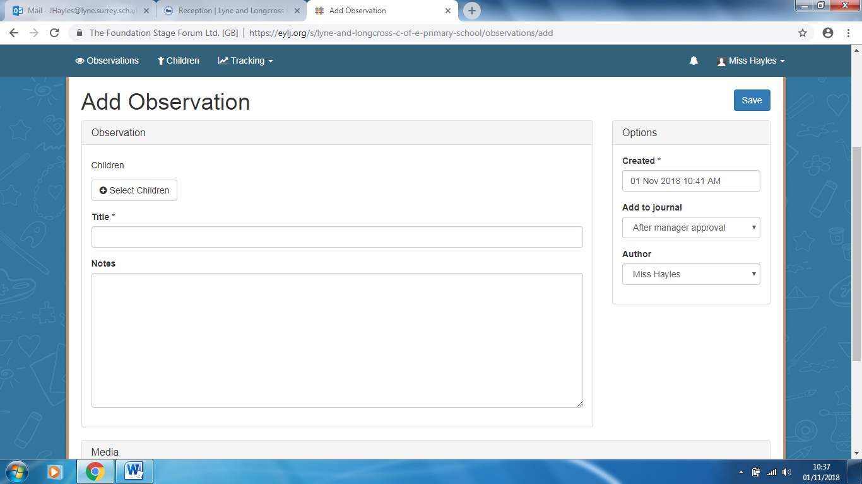
If you have any queries then please do ask
If you would like to add a photo/video(s) click on ‘Add Files’ and once you have added them click on ‘Start Upload’. Once you are happy with everything click on ‘Save’.
Your child will already be selected. Then type in a title for your observation. After that you can write notes about what observation is about.

